The Bavaria Cruiser 46 Style

EUR 700,000

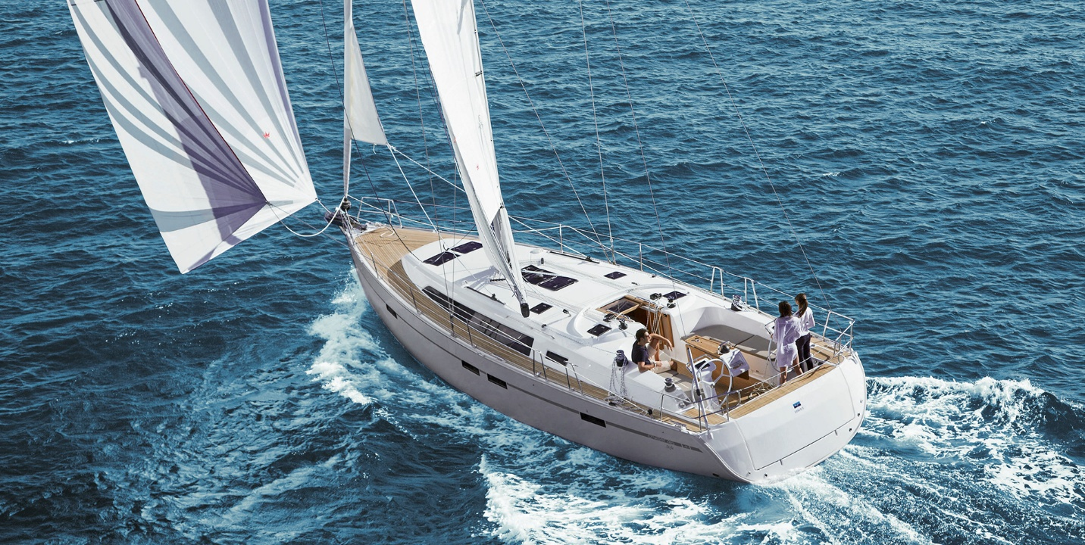

## Asking price: **EUR 700,000**

## Built: **2019, New England, Greater Boston**

## Length: **59.2m (290.6ft)**

## Cabins: **3**

## Berths: **6**

# Description:

# There is no other yacht quite as stylish.

### You will love spending time below deck. The BAVARIA CRUISER 46 Style takes your breath away with her luxurious interior design – the best materials, comfortable upholstery, classically elegant ambience and plenty of light. Plus the possibility of customisation – for example in the colour of wood, the floor and the choice of upholstery. Whatever you desire.